AUTOMOBILE INSURANCE ANALYSIS REPORT
Project Title
Automobile Insurance Complaint & Premium Analysis using Power BI, Tableau & Python
Objective
The objective of this project is to:
- Analyze complaint patterns across insurance companies
- Study complaint trends over time
- Evaluate premium growth and its impact
- Compare performance of top 5 companies
- Provide actionable business insights
Dataset Description
The dataset contains automobile insurance company data from New York State.
Key Fields:
- Company Name
- Complaint Ratio
- Upheld Complaints
- Question of Fact Complaints
- Not Upheld Complaints
- Total Complaints
- Premiums Written
- Filing Year
Data Preparation
- Data extracted from MySQL database
- Processed using Python (Pandas)
- Cleaned and converted to structured format
- Imported into Power BI and Tableau

1. Complaint Diagnostic Analysis
Complaint Types Over Years
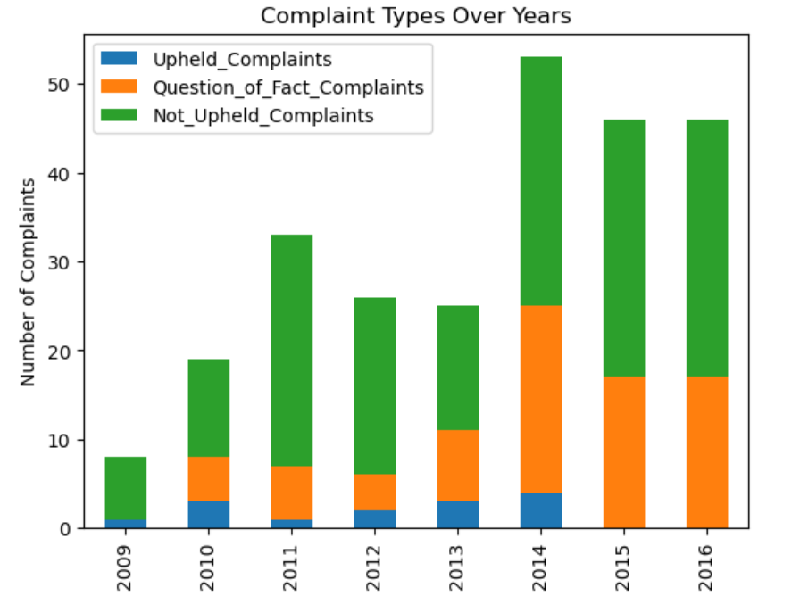

Insights:
- Not Upheld complaints dominate every year
- Upheld complaints are very low → indicates good service
- Complaint volume peaked around 2014

Total Complaints Trend
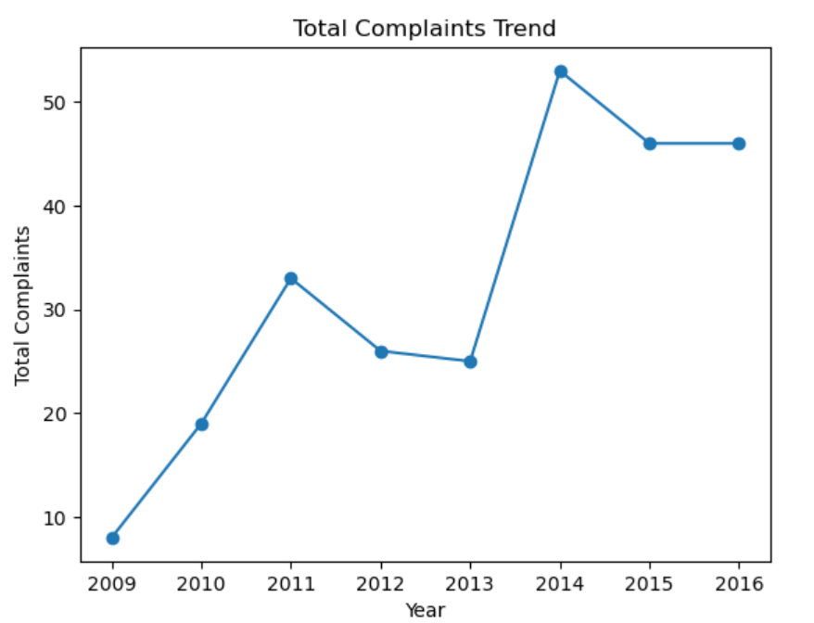

Insights:
- Complaints increased initially (2009–2011)
- Peak observed in 2014
- Decline after 2014 → improvement in operations

Complaint Ratio Trend
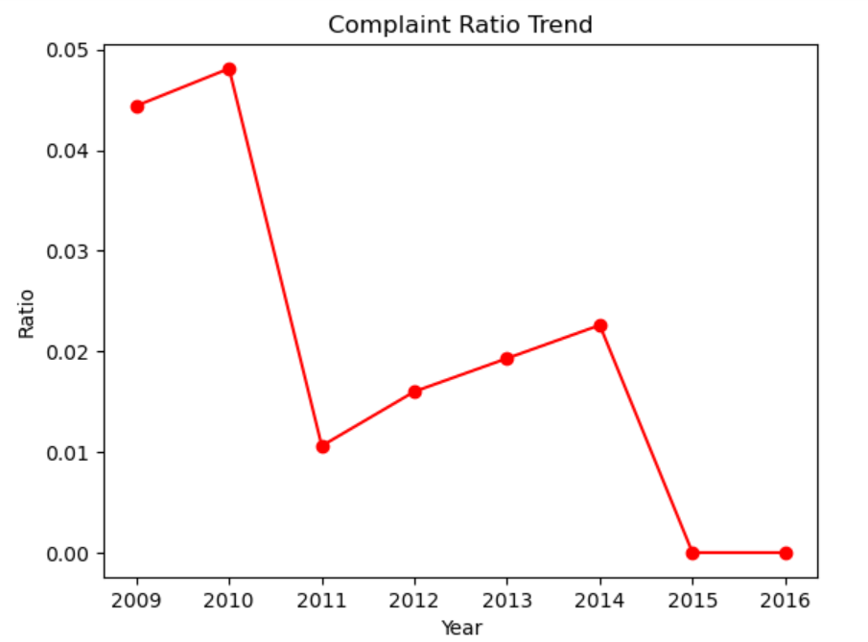

Insights:
- Highest ratio observed in early years (2009–2010)
- Significant drop after 2011
- Near zero ratio in 2015–2016 → excellent performance

2. Premium Analysis
Premium Trend
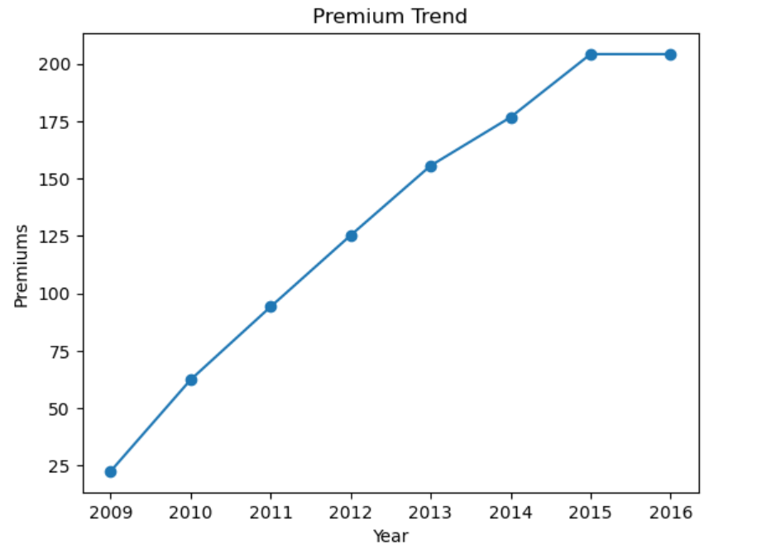

Insights:
- Continuous growth in premiums from 2009 to 2016
- Indicates:
  - Business expansion
  - Increased customer base

Premium vs Complaints
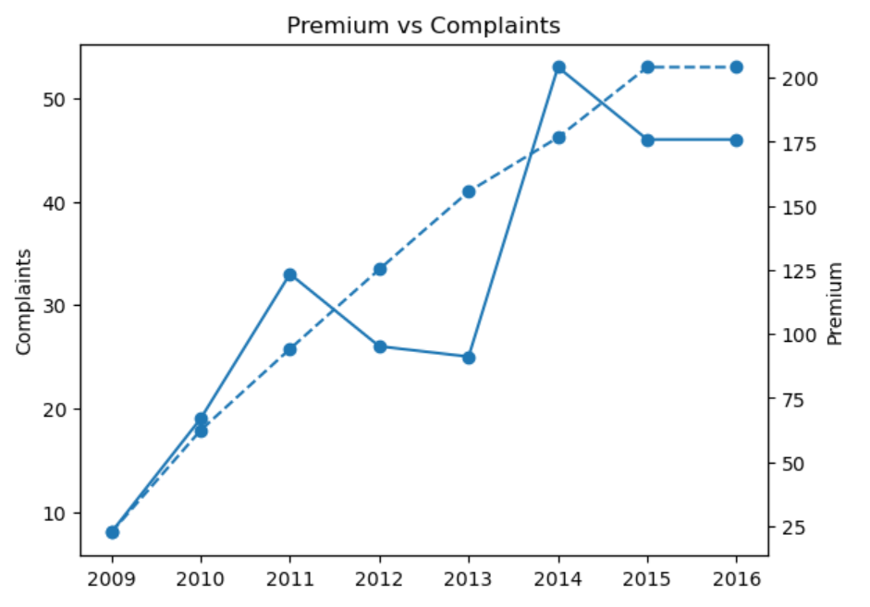

Insights:
- Premiums increased steadily
- Complaints fluctuated but stabilized
- Growth did not negatively impact service quality

3. Selected Company Analysis
Company:
Progressive Specialty Insurance Company
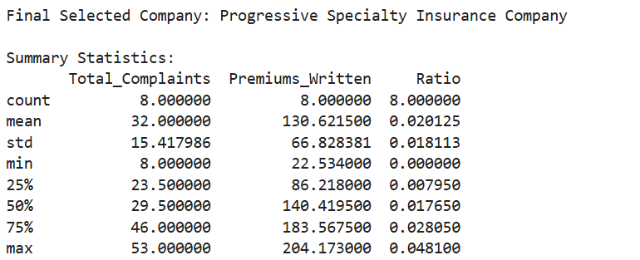

Key Findings:
- Average complaints: 32 per year
- Average premium: 130 million
- Average complaint ratio: ~2%
👉 Interpretation:
- Moderate complaints relative to business size
- Maintains stable performance over time

4. Dashboard Analysis (Power BI)
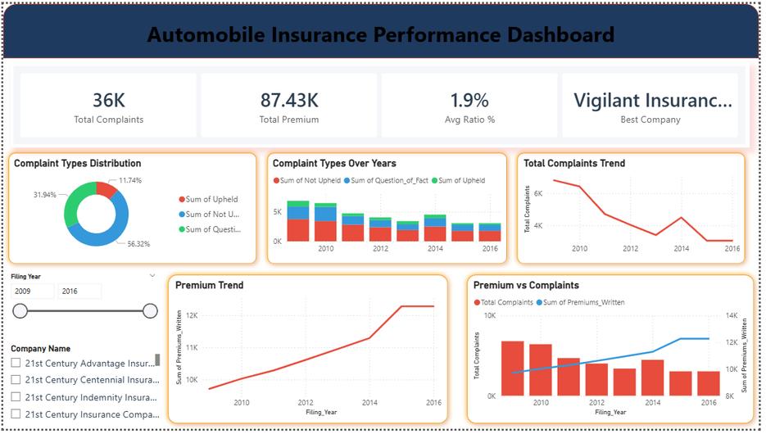

Features:
- KPI Cards:
  - Total Complaints: 36K
  - Total Premium: 87.43K
  - Avg Ratio: 1.9%
  - Best Company: Vigilant Insurance
- Visuals:
  - Complaint distribution
  - Complaint trends
  - Premium trends
  - Premium vs complaints
Key Insights:
- Majority complaints are not upheld
- Complaint ratio remains low
- Premium growth is consistent

5. Company Comparison (Tableau)
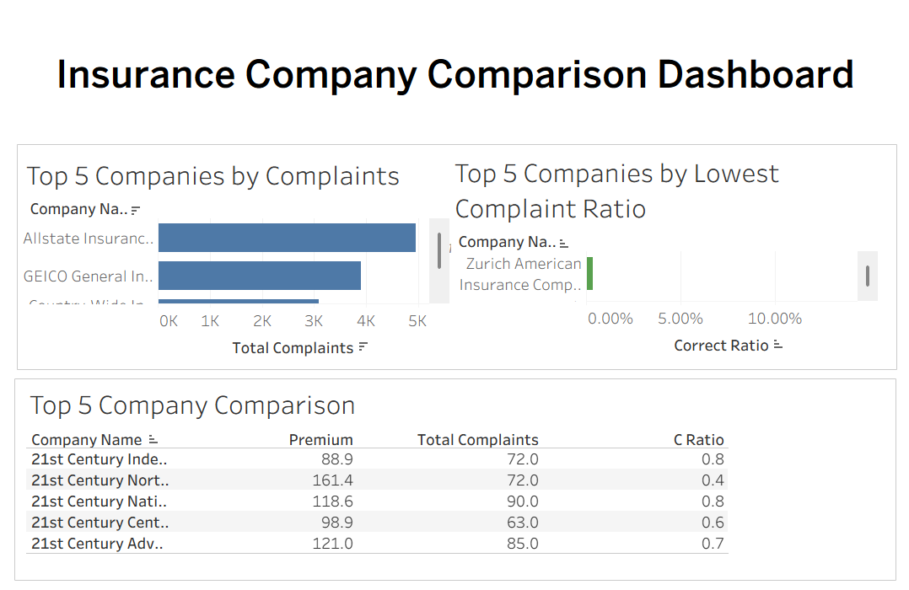

Top 5 Companies by Complaints
- Allstate Insurance
- GEICO
- State Farm
- Country-Wide Insurance
High complaint volume due to large customer base

Top 5 Companies by Lowest Complaint Ratio
- Zurich American
- Greater New York
- OneBeacon
Best performing companies

Comparison Table Insights
- Companies with low ratio show better service
- Higher premium does not always mean more complaints

6. Key Insights
- Most complaints are not upheld → customer misunderstanding or false claims
- Complaint ratio is generally low across companies
- Premium growth shows strong insurance market performance
- Companies with low complaint ratio provide better service

7. Conclusion
This analysis shows that:
Insurance companies are able to scale their business (increase premiums) while maintaining low complaint ratios, indicating strong operational efficiency and customer service quality.

8. Recommendations
- Improve customer awareness about policy terms
- Enhance claim transparency
- Monitor complaint ratio regularly
- Use dashboards for performance tracking

